Application of Big Data and Data Analytics:

Impact of Data and Statistics on Fantasy Basketball

Progress Report: 02/23/2020

Jacob Mitchell

Overview: Last sprint, I gathered materials and data files to perform calculations with after defining the objective of this research project. This sprint, I worked to get more familiar with the tools in which I’m going to be using. I’m going to be using a mixture of R and Python/Jupyter note books to analyze data. I’ve collected a couple of data sets and played around with making different plots to see what certain aspects of the data look like when plotted out to find trends.

Although the datasets I’m practicing with aren’t related to the project, they are helpful in gaining a more firm understanding of the tools I’m going to be working with. Below is some plots of data I learned to create using R studio.

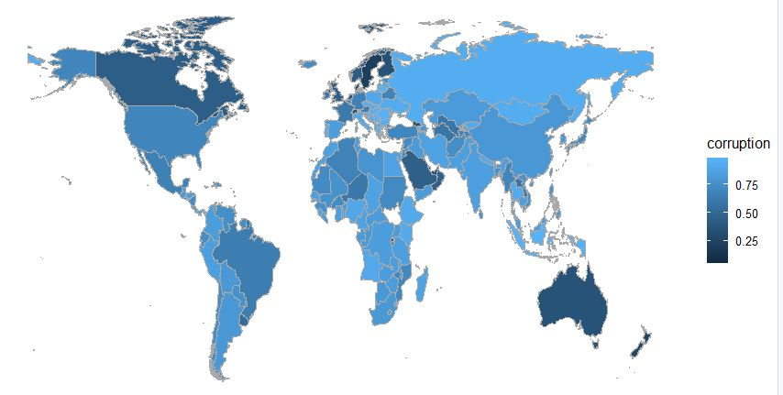

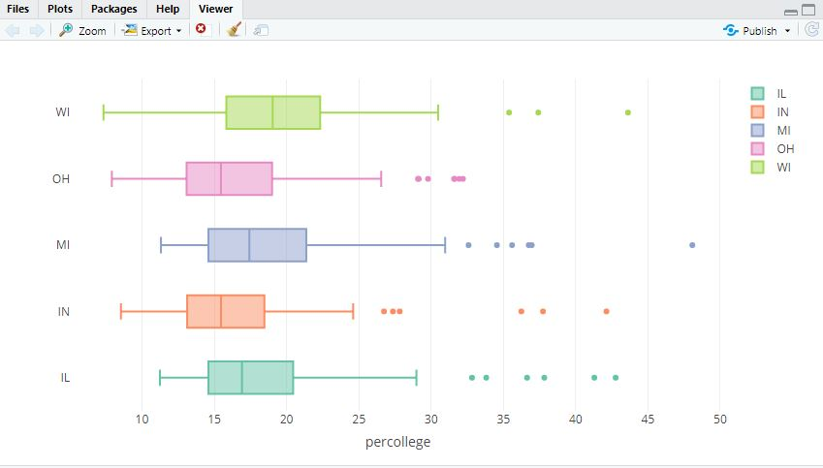

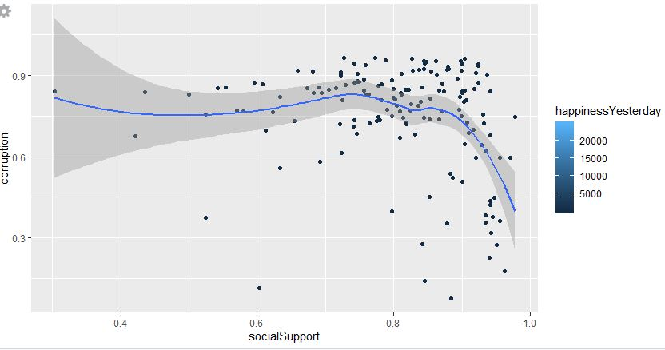

These tools will be useful in creating graphics that support and illustrate my findings related to NBA basketball.

Next sprint, I intend to begin plotting data for actual NBA statistics and seeing what patterns I can find in the data. Although I did get things done this sprint, I didn’t get as much done as I had hoped. I still hope to find helpful academic journals under the topic and actually get to working with related data.   
For my next sprint, I intend to start performing analytics using python, jupyter, and pandas, as well as at the very least knowing which academic journals I can reference that will be useful for this project.

I’m not as far as I hoped to be at this point, but I am still on track to completing this project in a timely manner.